

Email template:
Request for matched donations

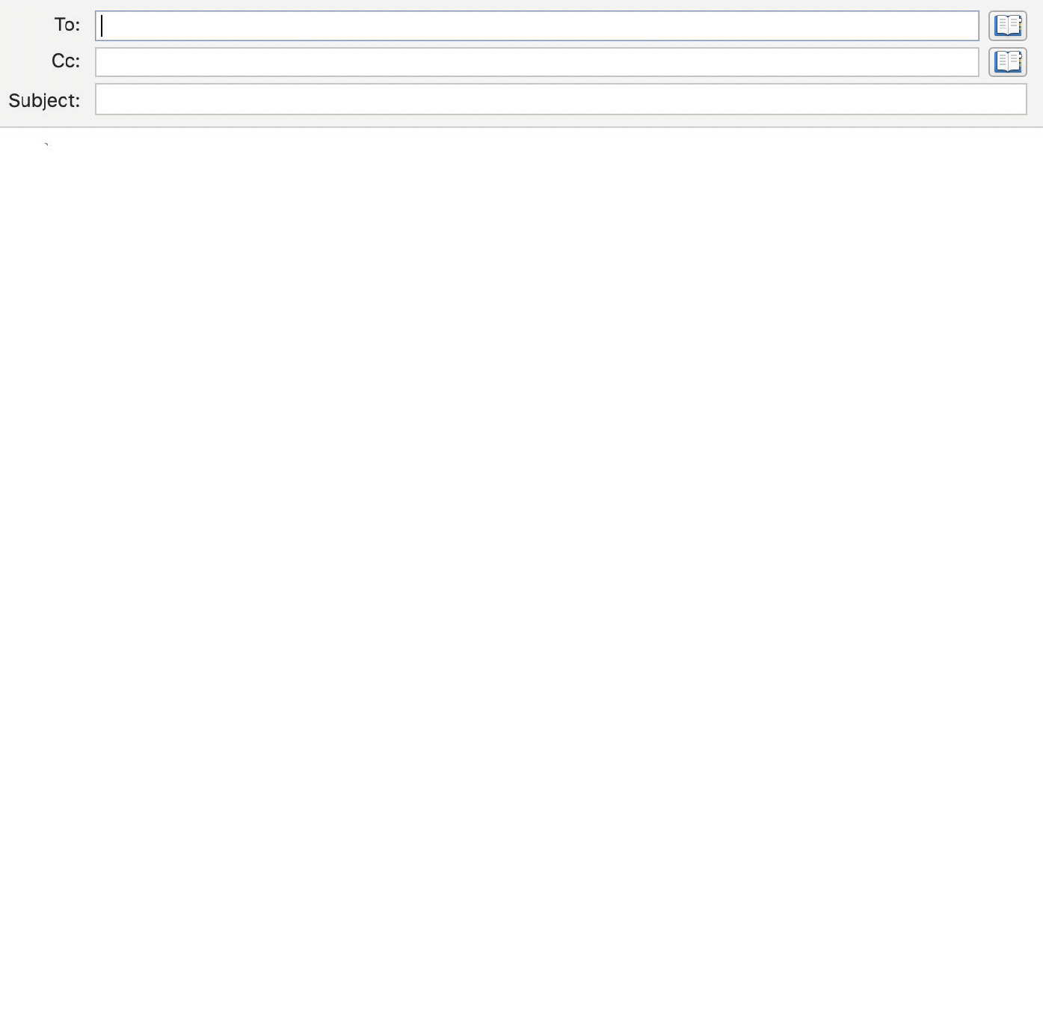

Jeans for Genes fundraiser – will you match me dollar for dollar?

Dear [employer],
I am excited to let you know that I’ll be taking part in Jeans for Genes Day on [Thursday August 7th/other date].
Did you know that 1 in 20 children face a birth defect or genetic disease?
When you think about that statistic—more than one child in every classroom—you know that you’ll be supporting a charity that impacts families across Australia.
Would [company name] consider supporting me in the form of dollar-for-dollar matching of the funds I raise?
All the money from Jeans for Genes goes towards ground-breaking medical research done in the labs at Children’s Medical Research Institute in Sydney. They are finding cures for blindness, cancer, metabolic disorders, and so much more.
When you support Jeans for Genes Day as a business, you are investing in the future health of generations of Australian children.
If you’d like to find out more about how our support will help, please visit their website JeansForGenes.org.au

Sincerely, [Name]

